1 : 1 단방향 식별관계, 대상테이블에 외래키 실습

STS -> Spring Stater Project , name : onetoone-3

SQL : JPA, MySQL 선택

<http://ojc.asia/bbs/board.php?bo_table=LecSpring&wr_id=524>

(마리아 DB 설치는 위 URL에서 참조)

**src/main/resources/application.properties**

spring.datasource.platform=mysql

spring.datasource.url=jdbc:mysql://localhost**/onetoone_3**?createDatabaseIfNotExist=true

spring.datasource.username=root

spring.datasource.password=1111

spring.datasource.driver-class-name=com.mysql.jdbc.Driver

spring.datasource.sql-script-encoding=UTF-8

spring.jpa.hibernate.ddl-auto=create

spring.jpa.show-sql=true

**demo.model.Emp.java**

@Entity

public class Emp {

@Id

@GeneratedValue

private Long empno;

private String ename;

public Emp(String ename) {

this.ename = ename;

}

public Long getEmpno() {

return empno;

}

public void setEmpno(Long empno) {

this.empno = empno;

}

public String getEname() {

return ename;

}

public void setEname(String ename) {

this.ename = ename;

}

@Override

public String toString() {

return String.format(

"Emp[empno=%d, ename='%s']",

empno, ename);

}

}

**demo.model.Addr.java**

package demo.model;

@Entity

public class Addr {

@Id private Long id;

private String address;

**//Addr 테이블에 empno 칼럼이 키로 생성**

**@OneToOne(cascade=CascadeType.ALL)**

**@MapsId**

**@JoinColumn(name="empno")**

private Emp emp;

public Addr(String address, Emp emp) {

this.address = address; this.emp = emp;

}

public Emp getEmp() { return emp; }

public void setEmp(Emp emp) {

this.emp = emp;

}

public Addr(String address) {

this.address = address; }

public String getAddress() {

return address; }

public void setAddress(String address) {

this.address = address;

}

}

**demo.repository.EmpRepository.java**

package demo.repository;

import org.springframework.data.jpa.repository.JpaRepository;

import demo.model.Emp;

public interface EmpRepository extends JpaRepository<Emp, Long> { }

**demo.repository.AddrRepository.java**

package demo.repository;

import org.springframework.data.jpa.repository.JpaRepository;

import demo.model.Addr;

public interface AddrRepository extends JpaRepository<Addr, Long>{ }

**demo.Onetoone3Application.java**

@SpringBootApplication

public class Onetoone3Application implements CommandLineRunner {

public static void main(String[] args) {

SpringApplication.run(Onetoone3Application.class, args);

}

@Autowired

EmpRepository empRepository;

@Autowired

AddrRepository addrRepository;

**@Transactional**

@Override

public void run(String...args) {

List<Emp> emps = new ArrayList();

emps.add(new Emp("김길동"));

emps.add(new Emp("나길동"));

emps.add(new Emp("다길동"));

empRepository.save(emps);

**//ALL Emp Display**

for(Emp e : empRepository.findAll()) {

System.out.println(e.toString());

}

Addr addr1 = new Addr("대전");

Emp e1 = new Emp("대전길동");

addr1.setEmp(e1);

Addr addr2 = new Addr("하와이");

addr2.setEmp(emps.get(0));

addrRepository.save(addr1);

addrRepository.save(addr2);

**//Addr에서 4번 "대전"을 삭제**

**//CascadeType.ALL 때문에 4번 "대전길동" 사원도 삭제됨**

Addr addr3 = addrRepository.findOne(4L);

addrRepository.delete(addr3);

}

}

**데이터 확인하기**



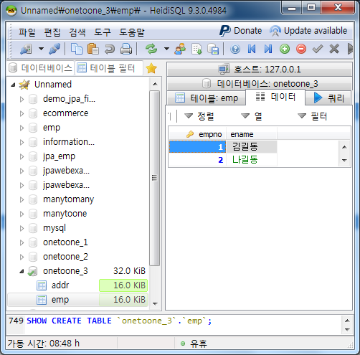

**[실행 결과]**

Hibernate: alter table addr drop foreign key FK_nqlgci8i855oq6mcrad87w5ks

Hibernate: drop table if exists addr

Hibernate: drop table if exists emp

Hibernate: create table addr (empno bigint not null, address varchar(255), primary key (empno))

Hibernate: create table emp (empno bigint not null auto_increment, ename varchar(255), primary key (empno))

Hibernate: alter table addr add constraint FK_nqlgci8i855oq6mcrad87w5ks foreign key (empno) references emp (empno)

Hibernate: insert into emp (ename) values (?)

Hibernate: insert into emp (ename) values (?)

Hibernate: insert into emp (ename) values (?)

Hibernate: select emp0_.empno as empno1_1_, emp0_.ename as ename2_1_ from emp emp0_

//메인 출력

Emp[empno=1, ename='김길동']

Emp[empno=2, ename='나길동']

Emp[empno=3, ename='다길동']

Hibernate: insert into emp (ename) values (?)

Hibernate: insert into addr (address, empno) values (?, ?)

Hibernate: insert into addr (address, empno) values (?, ?)

Hibernate: delete from addr where empno=?

Hibernate: delete from emp where empno=?